No. of Pages | 5
No. of Questions | 7

Department of Computer Science and Engineering
FINAL EXAMINATION SPRING 2011

CSE490: LAN Switching and WAN Technologies
Total Marks:75 Time Allowed: 3 Hours

- Answer any FIVE (5) questions out of the given SEVEN(7) questions.
- Figure in bracket [] next to each question indicates marks for that question.

Question No. 1

- You configure interface Fa0/1 as follows: [3 marks]
SW1(config-if)#switchport mode trunk
What is the native VLAN for this interface, and which VLANs can this interface handle?
- Explain what happens in MAC address flooding problem. [4 marks]
line vty 0 4
password 7 030752180500
login
transport input ssh

Figure No. 1

- The following output was taken from a configuration file of a switch. What does it imply? [3 marks]
- What is the advantage of using auto-MDIX command? [2 marks]
- Explain briefly at least two common problems associated with VLANs. [3 marks]

Question No. 2

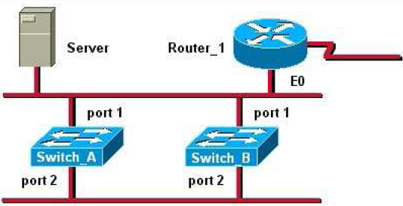
Figure No. 2

- Refer to the figure no. 2 above, the Server sends a broadcast frame to one of the PC connected to Switch B at port 2. If STP is not enabled, what will happen? [3 marks]
- Why might you use the command spanning-tree vlan 1 root secondary? [2 marks]
- For which type of interfaces do we disable spanning-tree port fast and why? [3 marks]

R1(config)#int f0/0.3
R1(config-subif)#encapsulation dot1q 20
R1(config-subif)#ip address 192.173.2.20 255.255.255.240
R1(config-subif)#end

Figure No. 3

- Refer to the commands shown in figure no. 3, the VLAN number and the router subinterface number do not match, will it be a problem? Explain yes or no. And will a PC with the IP address of 192.173.30/28 have the ip address of int fa0/0.3 as its default gateway? [4 marks]
- What is a ‘Router on a Stick’? State its advantages. [3 marks]

Question No. 3

- A client switch is reset. How does it obtain VLAN information? Mention the advertisements sent and received. [4 marks]

What is the purpose of including the configuration revision number in a VTP advertisement? Does the configuration revision number have an impact when you add an old and a new switch to an existing network? [4 marks]
- If VTP is not working correctly, what should you check? List steps. [3 marks]
- How does a layer 3 switch differ from a layer 2 switch? [2 marks]
- When do we use Transparent mode switches? [2 marks]

Question No. 4

- How are the statements of an Access Control List evaluated? As an ACL is compared, what happens when a parameter on the list matches an input of the packet compared? What is effect of the “implicit deny statement” here? [4 marks]
- Configure a named extended ACL (BROWSE) so that all hosts of the 192.162.10.96/27 network can access the isp web server having the IP address of 200.20.20.100 through http but cannot telnet the web server. All other traffic should be allowed. [4 marks]
- It is possible to edit named ACL, how? [3 marks]
- Configure a named standard ACL (NO_TELNET) so that only hosts of 192.168.10.32/27 and 192.168.10.64/27 networks should be able to telnet the BRACU router. But the rest should be denied. Do not forget to apply the ACL. [4 marks]

Question No. 5

- Configure HQ with a NAT server to dynamically assign global outside IP addresses from the NAT pool range of 137.38.39.40/29 to local inside packets attempting to access the Internet. Any packet with an IP address from the 192.168.1.0/28 network will be translated. [4 marks]
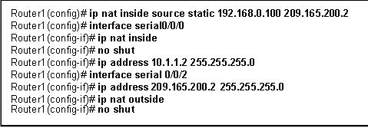
A
B
Figure No. 4
- Referring to the above figure no. 4, which host or hosts will be translated by NAT. [3 marks]
- What are the disadvantages of using NAT? [2 marks]
- In the figure no. 5 below, why are we excluding the addresses? Does it mean that we are not going to use these addresses? Explain. [3 marks]

Figure No. 5

- Differentiate between Automatic Allocation and Dynamic Allocation in DHCP. [3 marks]

Question No. 6

- List the phases of PPP operation. [2 marks]
- Compare between HDLC and PPP. [3 marks]
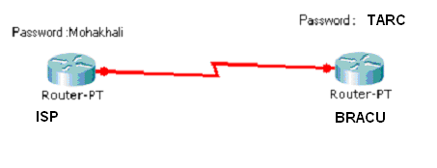
Figure No. 6
- Write down the necessary commands to enable PPP with PAP authentication for both routers in figure no.6. [4 marks]
- What happens next when the Remote router sends the challenge packet to the Local router in CHAP authentication process? [4 marks]
- What type of configuration parameters are negotiated during the Link establish phase? [2 marks]

Question No. 7

- What are the advantages of having Frame Relay over Leased dedicated lines for an organization having multiple branches in remote locations? [3 marks]

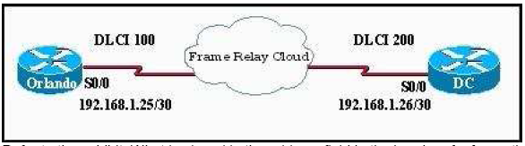
Figure No. 7
- Refer to the figure no. 7 above. What kind of virtual circuit does DLCI 100 represent? If DLCI 100 is also numbered as DLCI 200, would it make a difference? [4 marks]
- What functions are provided by the Local Management Interface used in Frame Relay networks? And what are the three standards? [3 marks]
- What is a FRAD in a frame-relay network? [2 marks]
- What is the difference between Static Frame Relay Map and Dynamic Frame Relay Map? [3 marks]

THE END

